INDEPENDENT COMMISSION AGAINST CORRUPTION

PARTICIPATION FORM

Category: Amateur Professional

Name of Group Leader (as per NIC):

Address:

Mobile number:

E-mail address:

Challenge:

Language:

Signature: __________________________ Date: __________________________

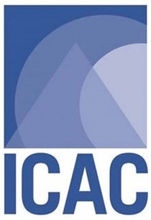 | Kindly submit this filled-in form via either:  - E-mail: pjoyram@icac.mu; or  - In-Person: ICAC, Réduit Triangle, Moka; or  - Post: The Supervising Officer, Corruption Prevention and Education Division, Independent Commission Against Corruption, Réduit Triangle, Moka  Deadline: Friday 15 October 2021  For more info, please contact Mr P.Joyram on 402 6907

***THANK YOU***

